

**EDGE: BU-CSE Digital Skills Training**

**University of Barishal (BU)**

|  |  |
| --- | --- |
| Puma Shoes Report  www.puma.com | **Abstract**  This report outlines Nike's business plan, emphasizing strategies in product innovation, marketing, and global expansion. Over the past five years, Nike has seen steady revenue growth, with a slight increase to $51.36 billion in 2024. The report highlights cost management, sustainability, and the company’s adaptive approach to market challenges. |

**Reported By:**

Najmul Islam

Batch: 041

Roll: 01-041-02

Table of Contents

**Executive Summary** 2

**Products and Services** 2

**Products** 2

➢ **Footwear** 2

➢ **Apparel** 2

➢ **Accessories** 3

➢ **Sustainability-Focused Products** 3

**Services** 4

▪ **Customization** 4

▪ **Collaborative Collections** 4

▪ **Athlete Sponsorships** 4

▪ **Eco-Friendly Initiatives** 4

▪ **Retail and E-Commerce Services** 4

**Business plan** 5

**Sales and cost statistics** 6

# 

# **Executive Summary**

Puma, a globally recognized sportswear brand, specializes in athletic and lifestyle footwear, apparel, and accessories. With a legacy dating back to 1948, Puma combines cutting-edge technology with innovative designs to deliver superior performance and style. The brand caters to athletes, fashion enthusiasts, and eco-conscious consumers, making it one of the most versatile and sought-after companies in the industry.

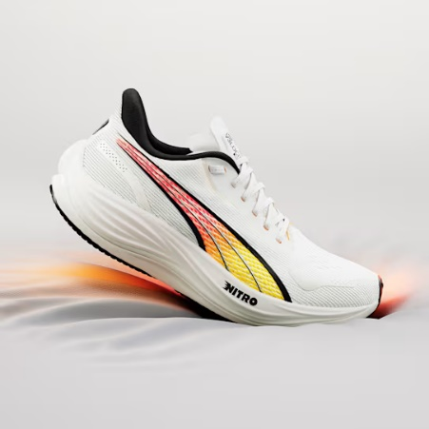

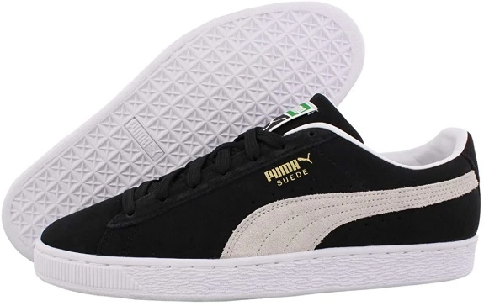

# **Products and Services**

Puma offers a wide range of high-quality products and services designed to cater to athletes, casual wearers, and fashion enthusiasts. The brand’s offerings include innovative footwear, performance-enhancing apparel, and versatile accessories. Below is a detailed overview of Puma’s key products and services:

## **Products**

### **Footwear**

* + - Performance Shoes:
      * Puma designs specialized shoes for activities such as running, football, basketball, and training. Example: [Puma Velocity Nitro 2](https://us.puma.com/us/en/pd/velocity-nitro-2-mens-running-shoes/195337) – lightweight running shoes with Nitro cushioning for enhanced comfort and responsiveness.
    - Casual Sneakers:
      * Stylish and versatile sneakers for everyday use. Example: [Puma Suede Classic](https://us.puma.com/us/en/collections/lifestyle/suede-collection) – timeless sneakers that blend comfort and iconic design.
    - Collaborative Collections:
      * Limited-edition footwear created in collaboration with celebrities and designers. Example: [Rihanna’s Fenty Puma Creepers](https://us.puma.com/us/en/fenty-x-puma-creeper-history).

### **Apparel**

* + - Sportswear:
      * High-performance sports apparel such as breathable training shirts, sweat-wicking shorts, and compression leggings.
      * Lifestyle Clothing:
      * Trendy t-shirts, jackets, and hoodies suitable for casual wear.

### **Accessories**

* + - Bags and Backpacks:
      * Durable bags designed for gym, travel, or everyday use. Example: Puma Challenger Duffel Bag.
    - Caps and Headwear:
      * Stylish caps for both athletes and casual wearers.

### **Sustainability-Focused Products**

* + - Recycled Materials:
      * Puma's RE:SUEDE initiative offers sneakers made from biodegradable and recycled materials.
    - Eco-Friendly Apparel:
      * Sustainable clothing lines that minimize environmental impact.

## **Services**

### **Customization**

* + Puma offers customers the ability to personalize their footwear and apparel, choosing colors, patterns, and even adding custom text.
  + Service Example: [PUMA x You](https://www.dakotakoop.com/work/puma) – A program allowing users to design custom sneakers online.

### **Collaborative Collections**

* + Puma partners with celebrities, designers, and sports teams to launch exclusive, limited-edition collections.
  + Examples:
    - [PUMA x Ferrari](https://ph.puma.com/ph/en/pd/scuderia-ferrari-drift-cat-delta-motorsport-shoes/306864.html) collection for motorsport enthusiasts.
    - PUMA x The Weeknd collaboration for streetwear lovers.

### **Athlete Sponsorships**

* + Puma supports professional athletes by providing sponsorships and performance-enhancing gear.
  + Examples: [Sponsorship of footballers](https://www.goal.com/en-in/news/which-footballers-sponsored-puma-pulisic-neymar-griezmann-list-brand-partners/blt946ceca8d0a8d156) like Neymar Jr. and Usain Bolt, the fastest man in the world.

### **Eco-Friendly Initiatives**

* + Puma offers programs for recycling old shoes and clothing, contributing to a circular economy.
  + Example: [Puma’s “Bring Back”](https://about.puma.com/en/node/1767) program, where customers return used products for recycling.

### **Retail and E-Commerce Services**

* + Global Stores:
    - Puma operates flagship stores and retail outlets in major cities worldwide.
  + Online Shopping:
    - Puma’s website provides an easy-to-navigate online shopping experience, featuring detailed product descriptions and virtual fitting tools.

# **Business plan**

Research & Development

Product Design and Innovation

Distribution and Sales

Manufacturing and Quality Assurance

Marketing and Branding

Customer Feedback and Continuous Improvement

# **Sales and cost statistics**

|  |  |  |  |
| --- | --- | --- | --- |
| **Year** | **Total Sales ($M)** | **Online Sales ($M)** | **Manufacturing Costs ($M)** |
| 2020 | 6,000 | 1,400 | 2,500 |
| 2021 | 6,800 | 2,100 | 2,900 |
| 2022 | 7,400 | 2,500 | 3,100 |
| 2023 | 8,200 | 2,600 | 3,100 |
| 2024 | 8,500 | 3,000 | 3,300 |